Computing the 3d Position of an Object from two Pan-Tilt cameras

Section 1
The need for obtaining one single PAN angle from both cameras is due to two facts:

1) Historically, the lab worked with a head that had a neck and needed a singular pan and tilt value (LVerge, RVerge, Pan, and Tilt). In the current configuration of the head, there are two independent pan and tilt values. Hence, there needed to be a conversion to obtain a single pan angle, “α”.

2) To compute the position of an object of interest marked by the angles of the cameras, a single pan and tilt angle are necessary to formulate distance equations for X, Y, and Z.

X = D
Y = y2
Z = Height

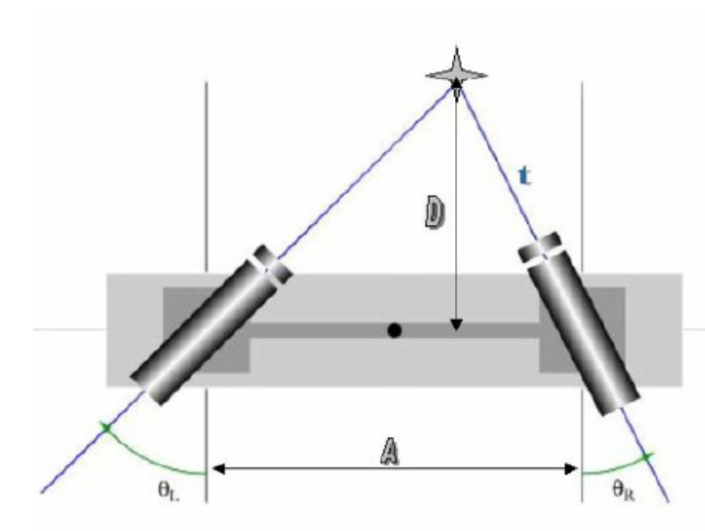
First, set the interior triangle angles as:

θ_{L}= 90 - B_{L}
θ_{R} = 90 – B_{R}

θ, we found t to be:

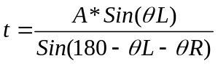

Simplifying,

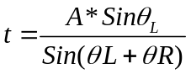

Hence, we find D = X to be:

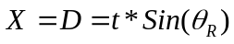

Substituting for t, and expanding the expression for D:

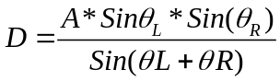

After having computed the distance, we now proceed to try to compute the singular value for the pan angle. From our diagram below and comparing it to the diagram above, we see that the pan value is the same as alpha, α:

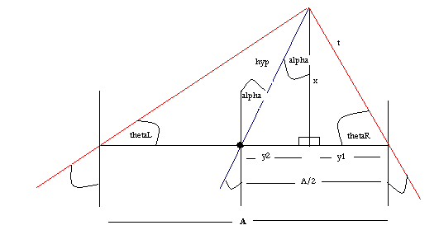

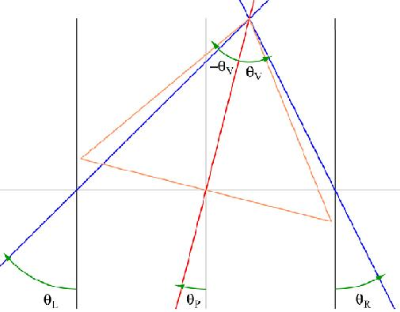 | 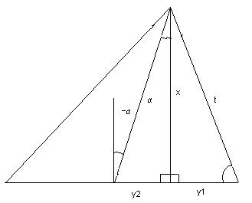

Now we want to find Y, which is equivalent to:
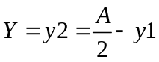

Since Y is a function of y1, we have to find the latter. Looking at the diagram, we can find the following relationship for y1:

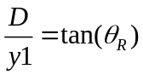

Substituting for D and solving for y1:

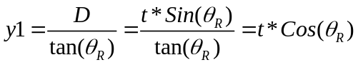

Hence, Y = y2 is:

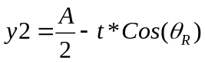

Next, we wish to find Z, which is the vertical height formed by both cameras. To find Z, we must first find the length of the hypotenuse formed by the singular pan angle.

hyp
height
φ_{tilt}

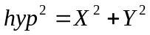

Z can then be computed by using the angle formed by the average tilt of both cameras:

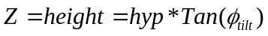

Section 2
Adjusting for the change in position in cameras

The trigonometric derivations done above are true when the base position of the cameras does not change. In our case, the cameras are mounted on a metal plate/platform that when they experience a tilt angle, the original position of the cameras is modified. This shift in position changes the true distance from the object of interest to the cameras.

A transform must be computed and added to the positions estimated in the previous section of this document to have a more accurate estimate of the distance.

First we will treat the tilt system and the pan system independently and see the kind of trigonometric expressions necessary for the transform. At the end, both sets of expressions will be combined into one set of equations.

Tilt System

Below is the PT system of the left camera as seen from a side-view:

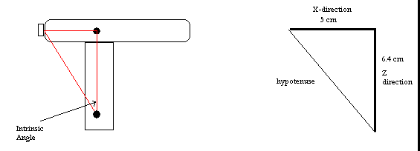
Camera at home position

As you can see, the measured X-distance from the front of the camera to it’s center point is 5 cm, and in the Z-direction, from it’s pivot to the center of mass it’s 6.4cm.

With these measurements we can compute an intrinsic angle here of:
atan2(5,6.4) = 37.9986,

And a hypotenuse of sqrt(5^2 + 6.4^2) = 8.1216.

Now, when the PT-system tilts, we come across the following configuration:

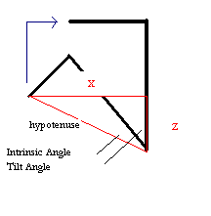
PT system at a negative angle (tilting down).

Our goal here is to find the difference in height and length produced by the change in tilt. A new triangle can be formed. The angle for this triangle will be the sum of the intrinsic angle plus the tilt. The hypotenuse is also the same value as before so we can find X and Z as follows:

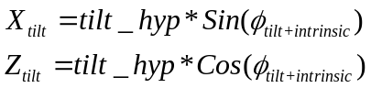

Once we compute these (negative) distances, we want to bring the overall computed distance for X and Z, to the center of mass. Consider the values computed in Section 1. And now we add onto those values to make sure that in the X-direction all values move back to the center point, same with Z.

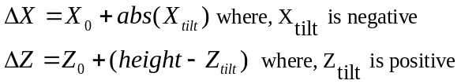

In effect, we are making X and Z slightly larger quantities to represent their real value.

Pan System

A similar operation is necessary with the pan angles. Consider the camera system from a top view:

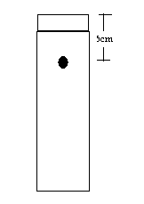
Pan angle home position

When the system pans in a clock-wise direction (negative angle), it forms the following geometry:

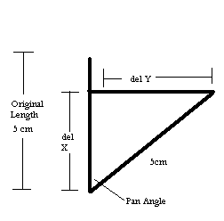
Pan at an angle

As before, our goal here is to find the difference in length and width produced by the change in pan. X and Y can be computed as:

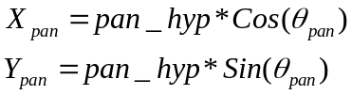

Once we compute these distances, then we can go ahead and compute the difference between the original length and width and the new positions:

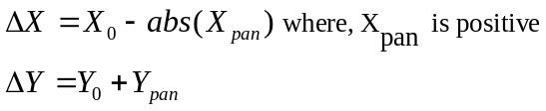
Unifying the Systems

When we combine the results for the two systems, we must understand that once the camera tilts, we then have a new X’ distance. This X’ distance can then be understood as the new pan angle hypotenuse in the presence of a pan angle. In other words, once the system tilts, the pan angle hypotenuse is no longer 5 cm, it’s going to be more. So, this new distance must be used to compute the results for the pan.

The equations look as follows:

%% Compute X and Z for the tilt
X_tilt = tilt_hyp*sind(tot_tilt_angle);
Z_tilt = tilt_hyp*cosd(tot_tilt_angle);

% Then interestingly enough, the result for the X_tilt become are new
% hypoteneuse for the pan computation, hence:
pan_hyp = abs(X_tilt);

%% Compute X_pan and Y_pan
X_pan = pan_hyp*cosd(pan_angle);
Y_pan = pan_hyp*sind(pan_angle);

%% So, an overall equation could be obtained as:
x_hat = tilt_hyp*sind(tot_tilt_angle)*cosd(pan_angle);
y_hat = tilt_hyp*sind(tot_tilt_angle)*sind(pan_angle);
Z_tilt = tilt_hyp*cosd(tot_tilt_angle);

An m-file was created to serve as a reference for this. It can be found at:
O:\\Documenation\\Component Description\\Head\\Head Change\\ Compute3DPosition_Section2.m

